Multilevel Truncated Negative Binomial Model Results

Fixed Effects Coefficients
Estimate | Std. Error | z value | P-value | Variable
1.5353 | 0.0387 | 39.7018 | 0.0000 | (Intercept)
-0.0012 | 0.0004 | -2.9885 | 0.0028 | import_from_slu_log
0.0055 | 0.0001 | 44.3899 | 0.0000 | age
-0.0272 | 0.0028 | -9.6268 | 0.0000 | state_unemployment
-0.0009 | 0.0001 | -7.2610 | 0.0000 | immigrant_density
0.0106 | 0.0035 | 3.0058 | 0.0026 | sex_enc1
0.0073 | 0.0121 | 0.6027 | 0.5467 | marital_status_enc1
0.0037 | 0.0043 | 0.8665 | 0.3862 | marital_status_enc2
-0.0484 | 0.0284 | -1.7075 | 0.0877 | employment_status_enc1
0.0973 | 0.0203 | 4.8057 | 0.0000 | employment_status_enc2
0.1910 | 0.0199 | 9.6196 | 0.0000 | purpose_simple1
0.4476 | 0.0158 | 28.4000 | 0.0000 | purpose_simple2
0.1347 | 0.0136 | 9.8814 | 0.0000 | purpose_simple3
0.0031 | 0.0159 | 0.1940 | 0.8462 | purpose_simple4
0.1367 | 0.0092 | 14.8746 | 0.0000 | accomd_type_enc1
0.2316 | 0.0053 | 43.8102 | 0.0000 | accomd_type_enc2
0.1075 | 0.0052 | 20.5681 | 0.0000 | season_enc1
0.0607 | 0.0052 | 11.5989 | 0.0000 | season_enc2
0.1534 | 0.0053 | 28.7773 | 0.0000 | season_enc3

Incident Rate Ratios (IRR) for Fixed Effects
Incident Rate Ratios for Fixed Effects
Variable | IRR | Lower CI | Upper CI | P-value
(Intercept) | 4.6429 | 4.3040 | 5.0085 | 0.0000
import_from_slu_log | 0.9988 | 0.9980 | 0.9996 | 0.0028
age | 1.0055 | 1.0053 | 1.0057 | 0.0000
state_unemployment | 0.9731 | 0.9678 | 0.9786 | 0.0000
immigrant_density | 0.9991 | 0.9988 | 0.9993 | 0.0000
sex_enc1 | 1.0107 | 1.0037 | 1.0177 | 0.0026
marital_status_enc1 | 1.0073 | 0.9837 | 1.0315 | 0.5467
marital_status_enc2 | 1.0037 | 0.9954 | 1.0121 | 0.3862
employment_status_enc1 | 0.9527 | 0.9012 | 1.0072 | 0.0877
employment_status_enc2 | 1.1022 | 1.0593 | 1.1469 | 0.0000
purpose_simple1 | 1.2104 | 1.1642 | 1.2585 | 0.0000
purpose_simple2 | 1.5645 | 1.5169 | 1.6136 | 0.0000
purpose_simple3 | 1.1442 | 1.1141 | 1.1752 | 0.0000
purpose_simple4 | 1.0031 | 0.9723 | 1.0349 | 0.8462
accomd_type_enc1 | 1.1465 | 1.1260 | 1.1673 | 0.0000
accomd_type_enc2 | 1.2606 | 1.2476 | 1.2737 | 0.0000
season_enc1 | 1.1135 | 1.1021 | 1.1249 | 0.0000
season_enc2 | 1.0626 | 1.0518 | 1.0736 | 0.0000
season_enc3 | 1.1658 | 1.1537 | 1.1781 | 0.0000

Random Effects Variance Components
No random effect variance estimated for region_census.

Variance Inflation Factor (VIF)
VIF Values (Note: VIF > 5 may indicate multicollinearity)
Variable | VIF
Predictor 1 | 1.22
Predictor 2 | 1.12
Predictor 3 | 1.01
Predictor 4 | 1.24
Predictor 5 | 1.02
Predictor 6 | 1.17
Predictor 7 | 1.00
Predictor 8 | 1.19
Predictor 9 | 1.15
Predictor 10 | 1.04

Model Comparison (Truncated vs Non-truncated)
ANOVA Model Comparison Results
Df | AIC | BIC | logLik | deviance | Chisq | Chi Df | Pr(>Chisq)
21 | 745,932.6 | 746,139.3 | -372,945.3 | 745,890.6
21 | 751,636.6 | 751,843.3 | -375,797.3 | 751,594.6 | 0 | 0 | 1

Model Fit Statistics
Statistic | Value
AIC | 745,932.6
BIC | 746,139.3
Log-likelihood | -372,945.3

Predicted vs Observed Length of Stay
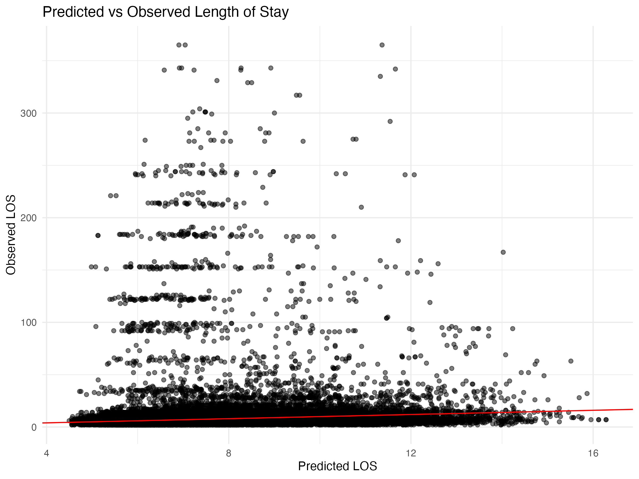

Diagnostic Plots

DHARMa Residuals
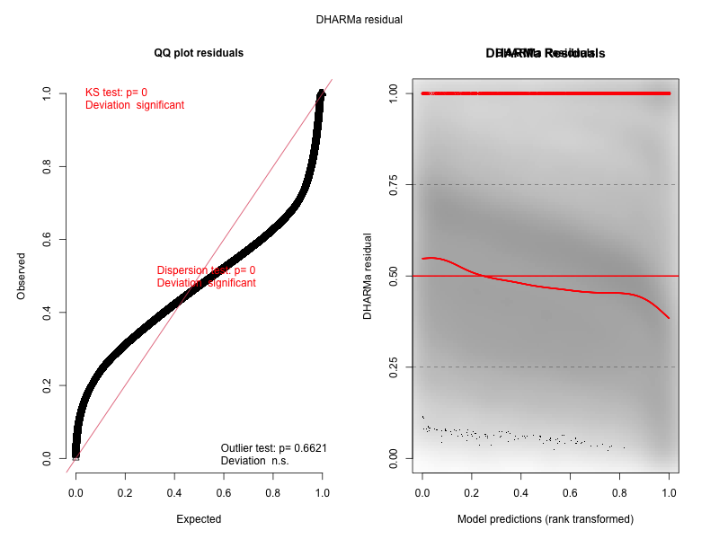

Residuals by State
